Constructing Triangle Centers

Definition
# Source: AI Source: Provided by: [Data Path: Persons Table -> ID Column: 1, Name_En Column: Motasem Essam] -> From: [ChatGPT] on [7/25/2026]
Constructing Triangle Centers is the process of locating the special points of a triangle by constructing specific lines or segments—such as perpendicular bisectors, angle bisectors, medians, and altitudes—whose intersections determine the centers.
A triangle has several important centers, each defined by a particular set of concurrent lines.
$$\boxed{\text{Triangle}→\text{Construct Special Lines}→\text{Find Their Intersection}→\text{Triangle Center}}$$

Simple Definition
# Source: AI Source: Provided by: [Data Path: Persons Table -> ID Column: 1, Name_En Column: Motasem Essam] -> From: [ChatGPT] on [7/25/2026]
Constructing Triangle Centers means using geometric construction methods to locate important special points inside or around a triangle.
The principal classical triangle centers are:
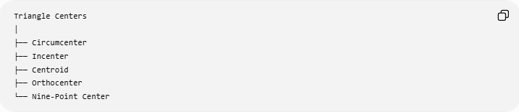
Triangle Centers
│
├── Circumcenter
├── Incenter
├── Centroid
├── Orthocenter
└── Nine-Point Center
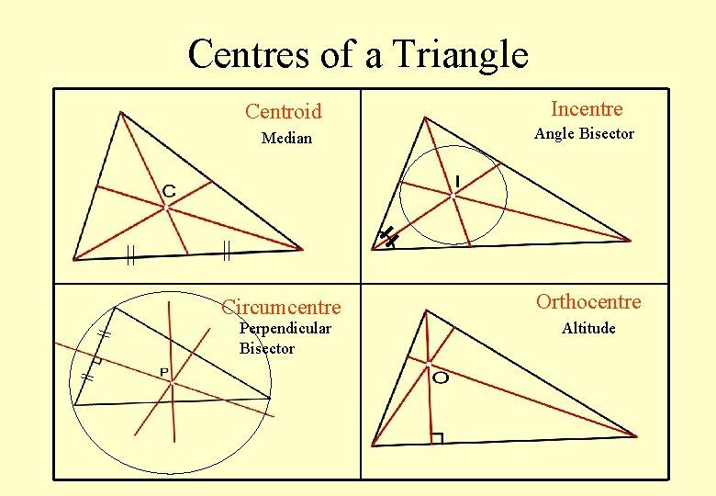
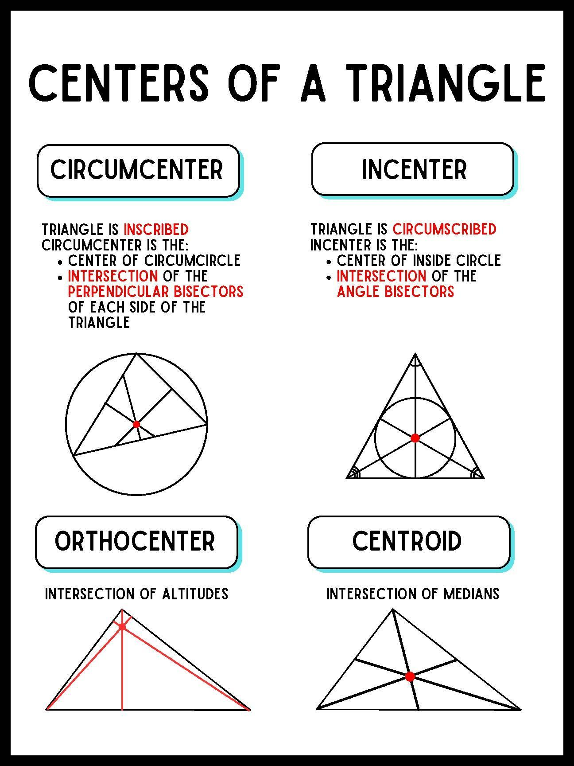
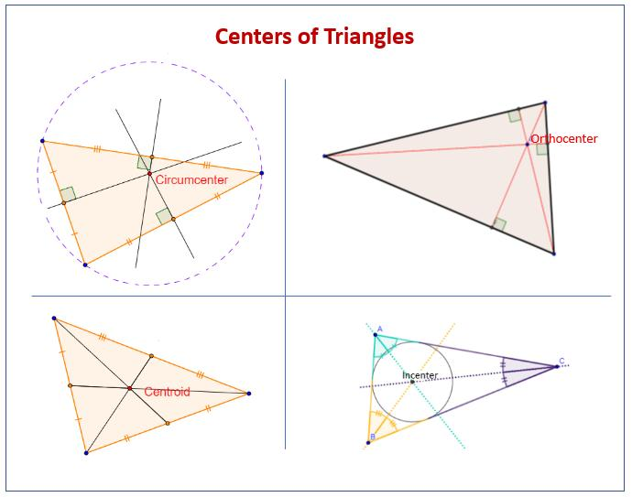
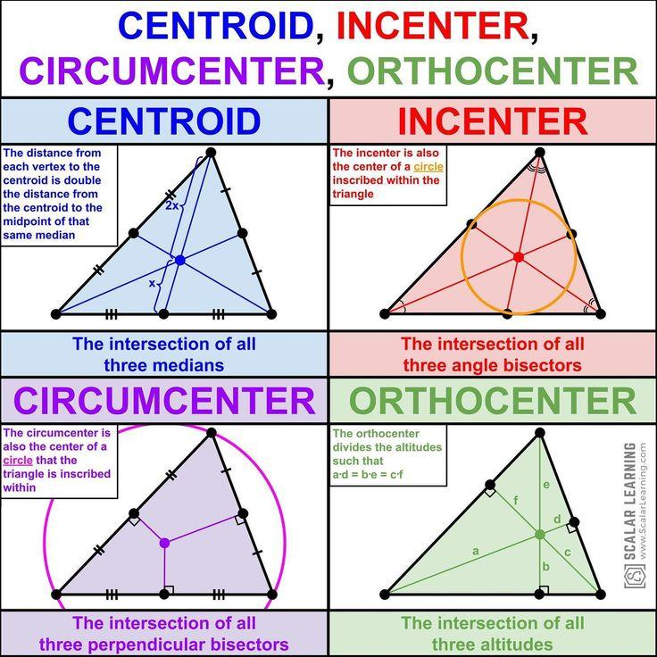
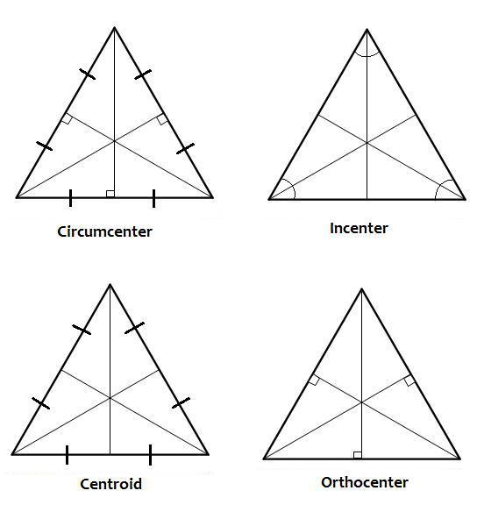

Fundamental Concept
# Source: AI Source: Provided by: [Data Path: Persons Table -> ID Column: 1, Name_En Column: Motasem Essam] -> From: [ChatGPT] on [7/25/2026]
Each center is constructed using a different family of special lines.
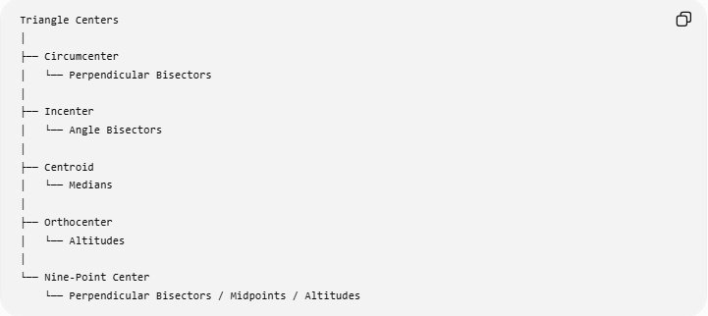
Triangle Centers
│
├── Circumcenter
│ └── Perpendicular Bisectors
│
├── Incenter
│ └── Angle Bisectors
│
├── Centroid
│ └── Medians
│
├── Orthocenter
│ └── Altitudes
│
└── Nine-Point Center
└── Perpendicular Bisectors / Midpoints / Altitudes
The key idea is concurrency:
$$\boxed{\text{Several constructed lines intersect at one common point}}$$
That common point is the corresponding triangle center.

Circumcenter Construction
# Source: AI Source: Provided by: [Data Path: Persons Table -> ID Column: 1, Name_En Column: Motasem Essam] -> From: [ChatGPT] on [7/25/2026] # Source: AI Source: Provided by: [Data Path: Persons Table -> ID Column: 1, Name_En Column: Motasem Essam] -> From: [ChatGPT] on [7/25/2026]
Definition
The circumcenter is the point where the three perpendicular bisectors of a triangle's sides intersect.
For:
$$△ABC,$$
construct the perpendicular bisectors of:
$$AB, BC, CA.$$
Their common intersection is the circumcenter $O$.
$$\boxed{O=\text{intersection of the perpendicular bisectors}}$$
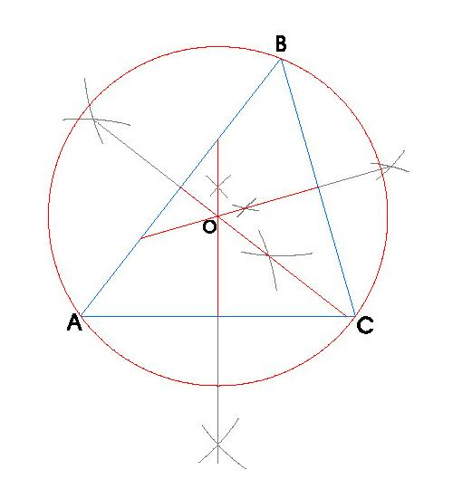
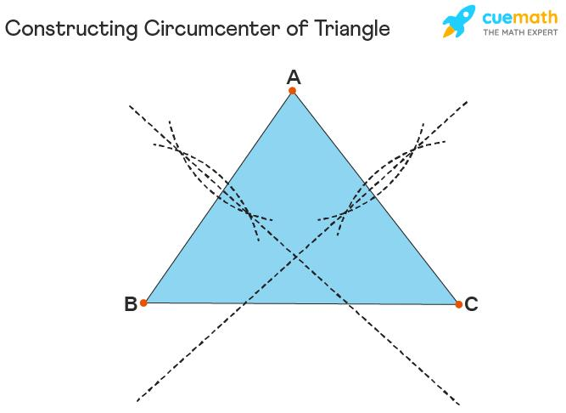
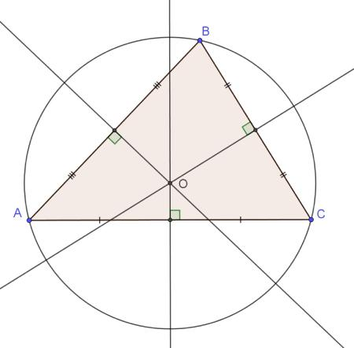
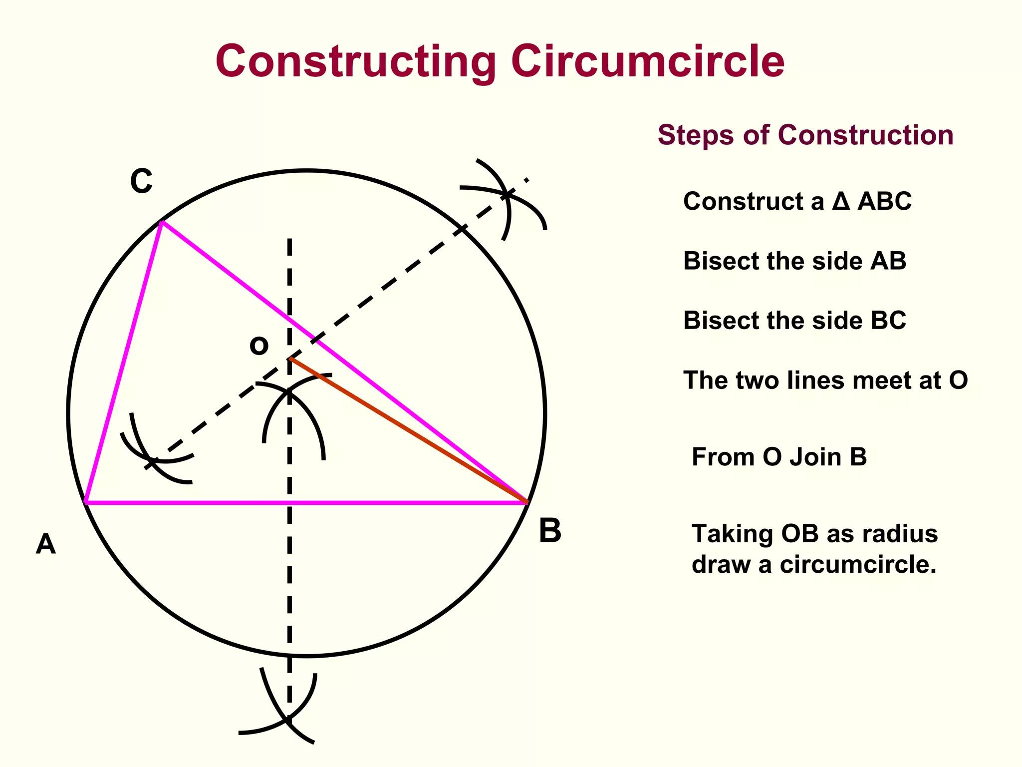
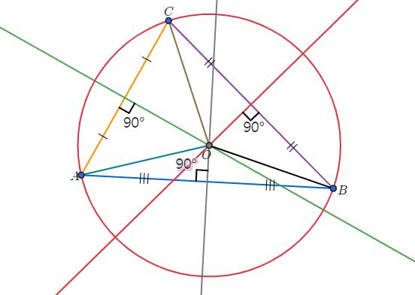
Construction
- Construct the perpendicular bisector of $AB$.
- Construct the perpendicular bisector of $BC$.
- Let them intersect at $O$.
- The perpendicular bisector of $CA$also passes through $O$.
Therefore:
$$\boxed{O∈\text{perpendicular bisectors of all three sides}}$$
Equality Produced
Because $O$lies on the perpendicular bisectors:
$$\boxed{OA=OB=OC}$$
Therefore a circle centered at $O$through $A,B,C$is the circumcircle.
$$\boxed{R=OA=OB=OC}$$
Location
- Acute triangle → circumcenter inside.
- Right triangle → circumcenter at midpoint of hypotenuse.
- Obtuse triangle → circumcenter outside.

Incenter Construction
# Source: AI Source: Provided by: [Data Path: Persons Table -> ID Column: 1, Name_En Column: Motasem Essam] -> From: [ChatGPT] on [7/25/2026]
Definition
The incenter is the point where the three internal angle bisectors of a triangle intersect.
For:
$$△ABC,$$
construct the internal angle bisectors of:
$$∠A, ∠B, ∠C.$$
Their common intersection is $I$.
$$\boxed{I=\text{intersection of the three internal angle bisectors}}$$
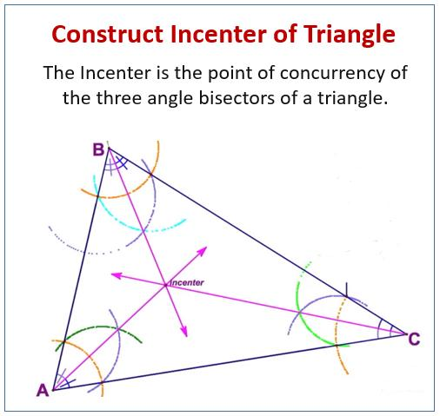
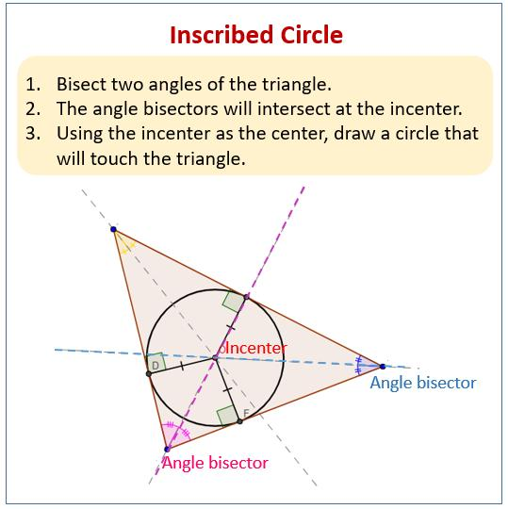
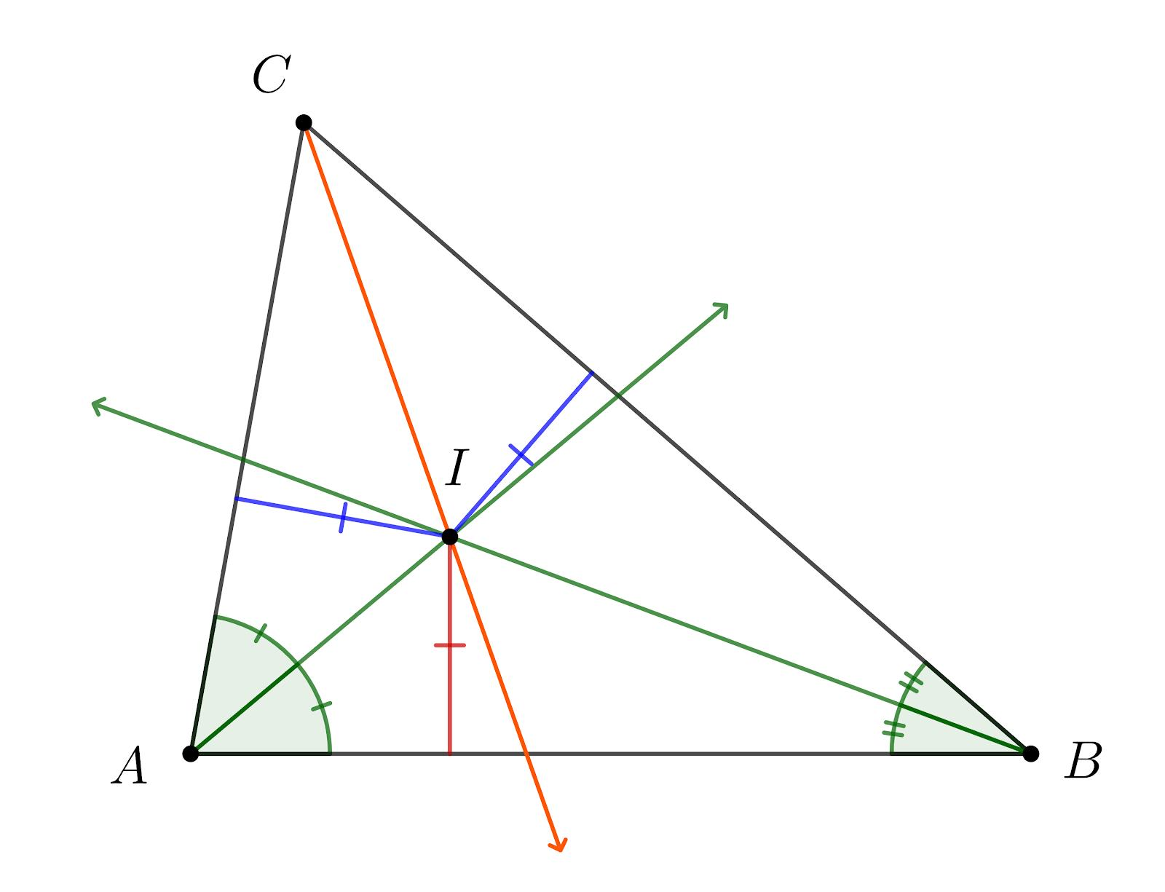
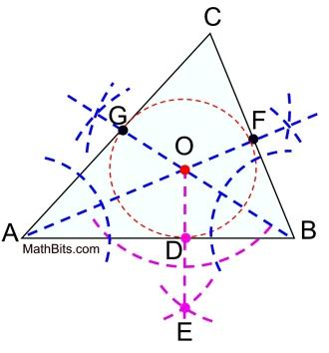
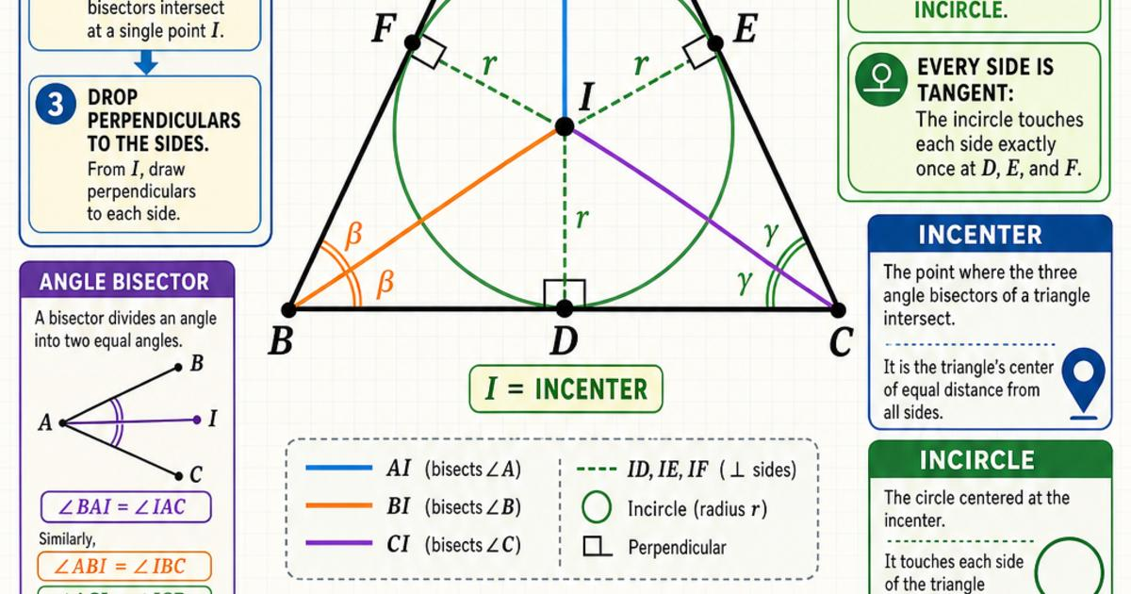
Construction
- Construct the bisector of $∠A$.
- Construct the bisector of $∠B$.
- Let them intersect at $I$.
- The bisector of $∠C$also passes through $I$.
The construction produces:
$$\boxed{∠BAI=∠IAC} \\ \boxed{∠ABI=∠IBC} \\ \boxed{∠ACI=∠ICB}$$
The incenter is equidistant from the three sides:
$$\boxed{d\left(I , AB\right)=d\left(I , BC\right)=d\left(I , CA\right)}$$
These equal distances define the radius of the incircle.

Centroid Construction
# Source: AI Source: Provided by: [Data Path: Persons Table -> ID Column: 1, Name_En Column: Motasem Essam] -> From: [ChatGPT] on [7/25/2026]
Definition
The centroid is the point where the three medians of a triangle intersect.
A median connects a vertex to the midpoint of the opposite side.
For:
$$△ABC,$$
construct:
$$D=\text{midpoint of }BC, \\ E=\text{midpoint of }CA, \\ F=\text{midpoint of }AB.$$
Then construct:
$$AD, BE, CF.$$
Their common intersection is the centroid $G$.
$$\boxed{G=AD∩BE∩CF}$$
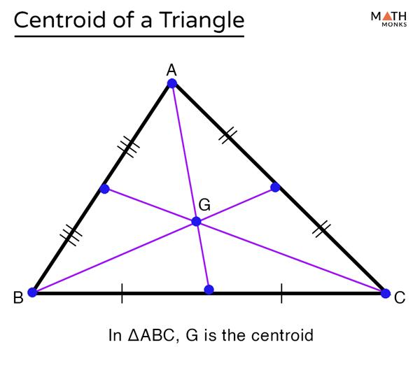
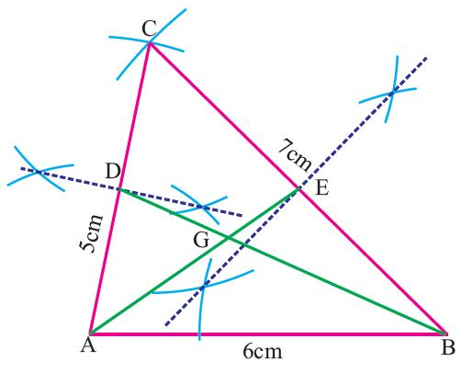
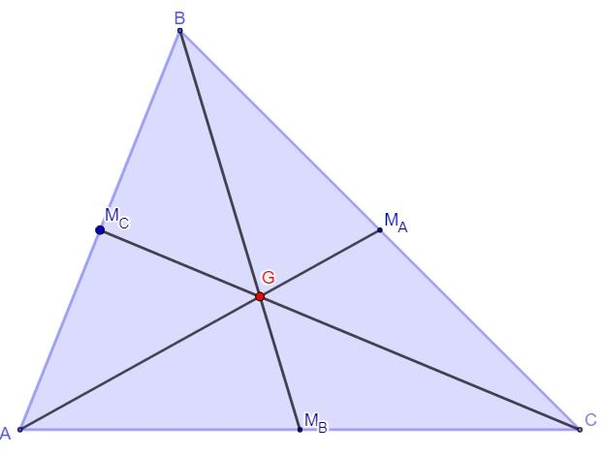
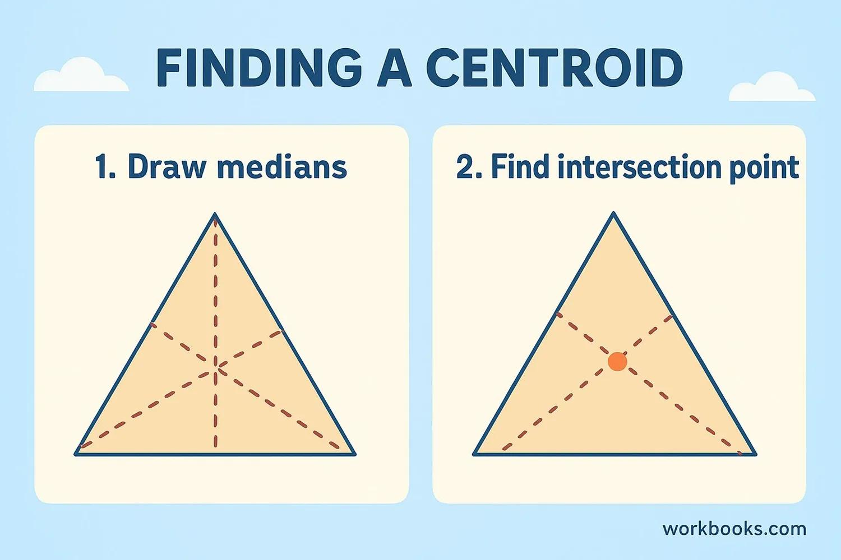
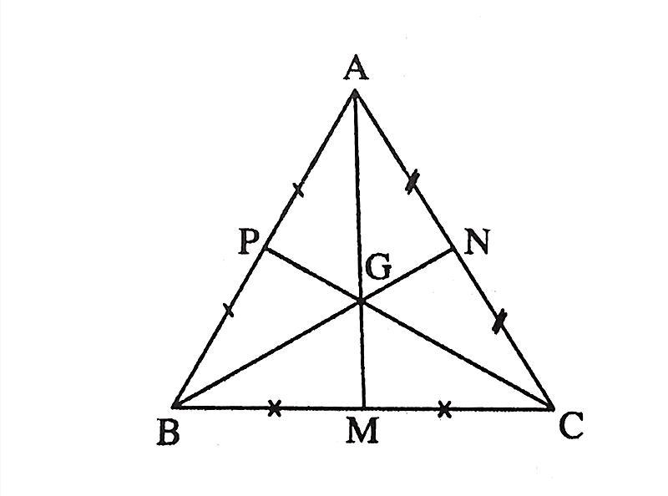
Construction
- Construct the midpoint $D$of $BC$.
- Draw median $AD$.
- Construct the midpoint $E$of $CA$.
- Draw median $BE$.
- Their intersection is $G$.
The third median $CF$also passes through $G$.
Important Relationship
The centroid divides each median in the ratio:
$$\boxed{AG:GD=2:1}$$
Similarly:
$$\boxed{BG:GE=2:1}$$
and:
$$\boxed{CG:GF=2:1}.$$
The centroid is always inside a non-degenerate triangle.

Orthocenter Construction
# Source: AI Source: Provided by: [Data Path: Persons Table -> ID Column: 1, Name_En Column: Motasem Essam] -> From: [ChatGPT] on [7/25/2026]
Definition
The orthocenter is the point where the three altitudes of a triangle intersect.
An altitude is a line through a vertex perpendicular to the opposite side or its extension.
For:
$$△ABC,$$
construct:
$$AD⊥BC.$$
Then construct another altitude:
$$BE⊥AC.$$
Their intersection is $H$, the orthocenter.
$$\boxed{H=AD∩BE}$$
The third altitude also passes through $H$.
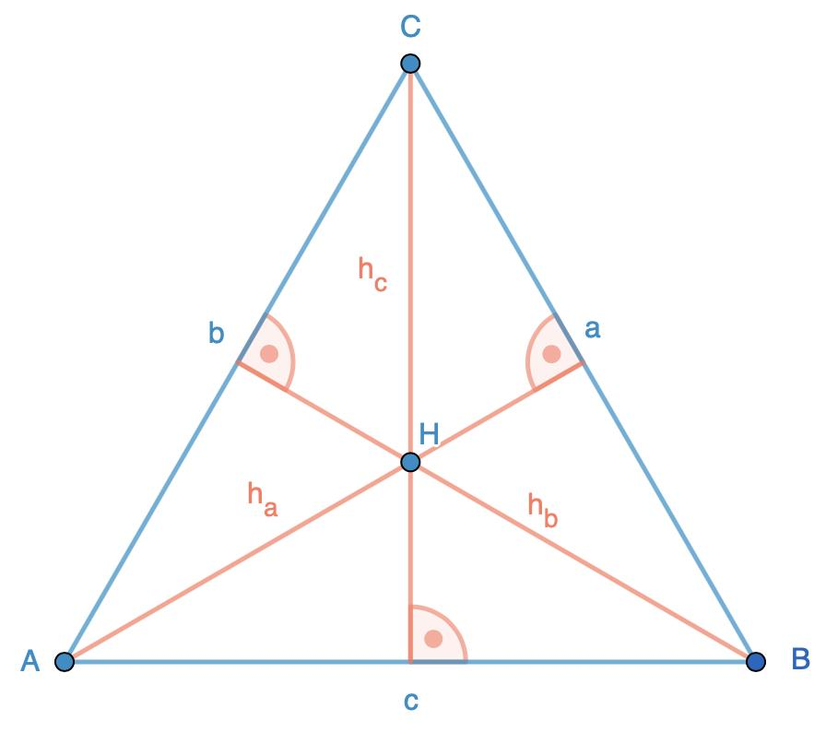
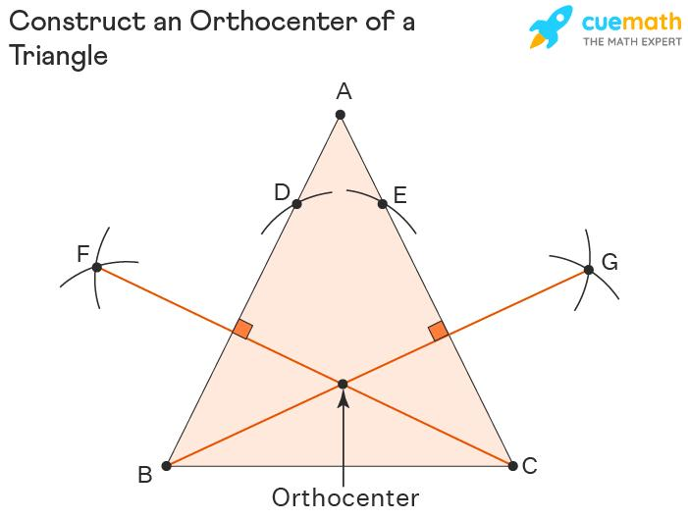
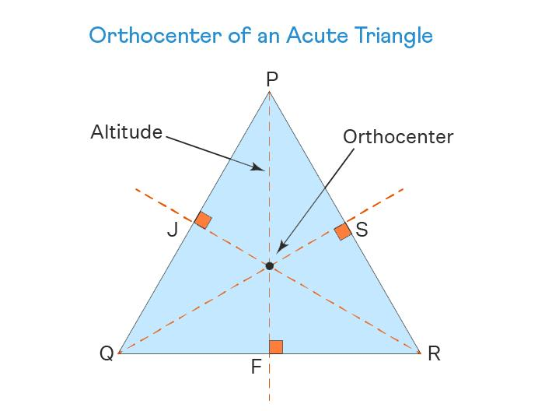
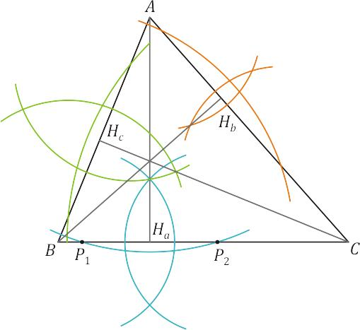
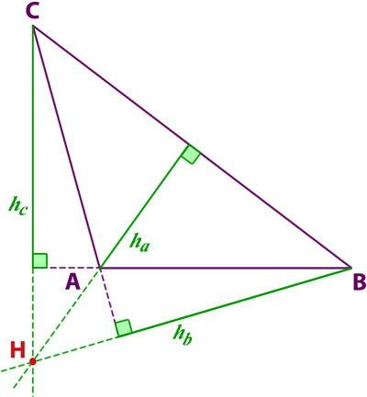
Construction
- Construct the perpendicular from $A$to $BC$.
- Construct the perpendicular from $B$to $AC$.
- Let them intersect at $H$.
- The altitude from $C$also passes through $H$.
Therefore:
$$\boxed{H=\text{intersection of the three altitudes}}$$
Location
- Acute triangle → orthocenter inside.
- Right triangle → orthocenter at the right-angle vertex.
- Obtuse triangle → orthocenter outside.

Nine-Point Center Construction
# Source: AI Source: Provided by: [Data Path: Persons Table -> ID Column: 1, Name_En Column: Motasem Essam] -> From: [ChatGPT] on [7/25/2026]
Definition
The nine-point center is the center of the nine-point circle of a triangle.
The nine-point circle passes through:
- The three side midpoints.
- The three feet of the altitudes.
- The three midpoints between each vertex and the orthocenter.
Its center is called the nine-point center, usually $N$.
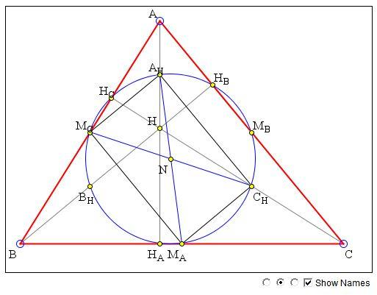
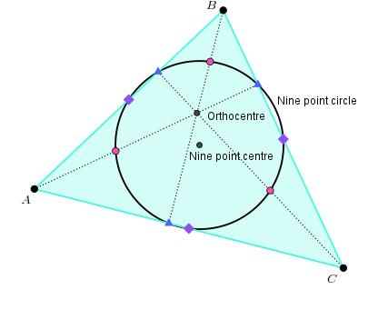
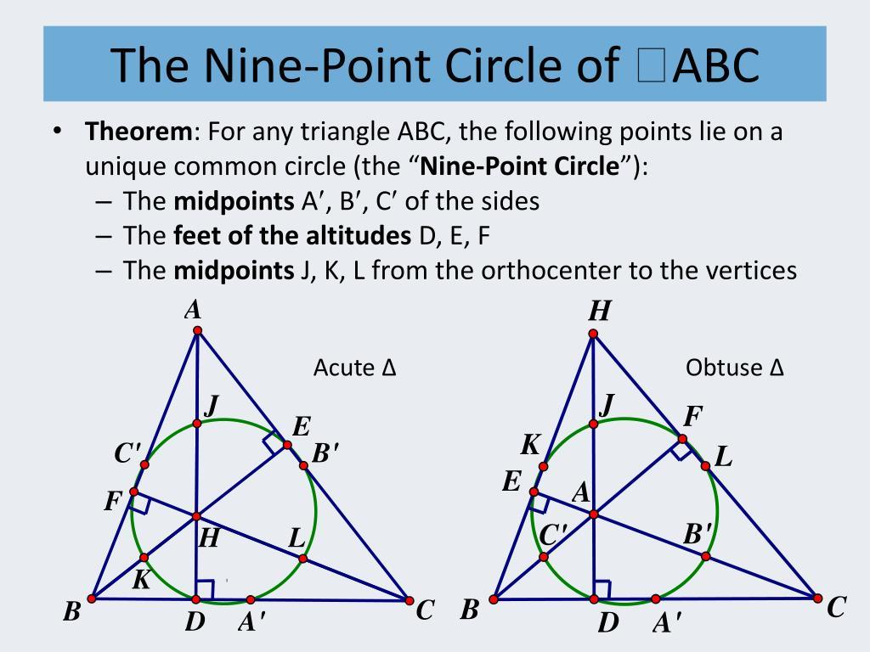
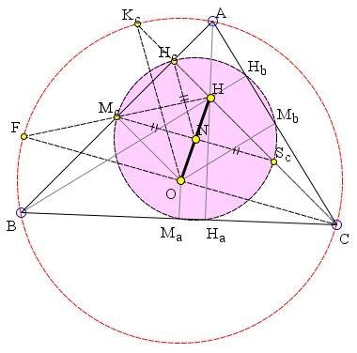
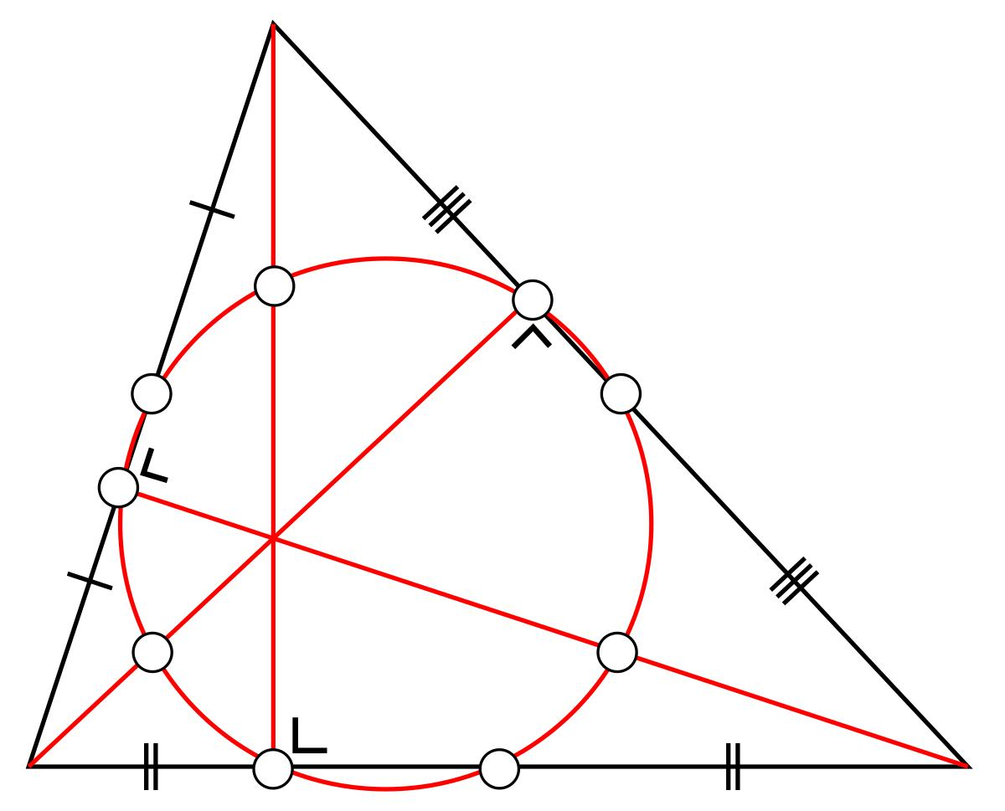
Construction Principle
For:
$$△ABC,$$
construct:
- the midpoints of $AB,BC,CA$,
- the feet of the three altitudes,
- the orthocenter $H$,
- the midpoints of $AH,BH,CH$.
These nine points lie on one circle.
The center of that circle is $N$.
An important relationship involving the circumcenter $O$and orthocenter $H$is:
$$\boxed{N\text{ is the midpoint of }OH}$$
Therefore:
$$\boxed{ON=NH}$$
and:
$$\boxed{R_{\text{nine-point}}=\frac{R}{2}}$$
where $R$is the circumradius.

Construction of the Circumcircle
# Source: AI Source: Provided by: [Data Path: Persons Table -> ID Column: 1, Name_En Column: Motasem Essam] -> From: [ChatGPT] on [7/25/2026]
Once the circumcenter $O$has been constructed:
$$OA=OB=OC.$$
Use $O$as the center and $OA$as the compass radius.
Draw the circle.
Then:
$$\boxed{OA=OB=OC=R}$$
The resulting circle passes through all three vertices.
$$\boxed{\text{Circumcenter}→\text{Circumcircle}}$$

Construction of the Incircle
# Source: AI Source: Provided by: [Data Path: Persons Table -> ID Column: 1, Name_En Column: Motasem Essam] -> From: [ChatGPT] on [7/25/2026]
Once the incenter $I$has been constructed, drop a perpendicular from $I$to any side.
Suppose:
$$ID⊥AB.$$
Then:
$$\boxed{r=ID}$$
where $r$is the inradius.
Because the incenter is equally distant from all three sides:
$$\boxed{ID=IE=IF=r}$$
Draw a circle centered at $I$with radius $r$.
This produces the incircle.
$$\boxed{\text{Incenter}→\text{Incircle}}$$

Relationship Between Centers and Their Constructions
# Source: AI Source: Provided by: [Data Path: Persons Table -> ID Column: 1, Name_En Column: Motasem Essam] -> From: [ChatGPT] on [7/25/2026]
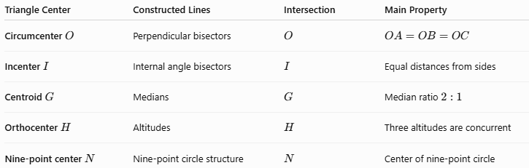
Triangle Center | Constructed Lines | Intersection | Main Property
Circumcenter $O$ | Perpendicular bisectors | $$O$$ | $$OA=OB=OC$$
Incenter $I$ | Internal angle bisectors | $$I$$ | Equal distances from sides
Centroid $G$ | Medians | $$G$$ | Median ratio $2:1$
Orthocenter $H$ | Altitudes | $$H$$ | Three altitudes are concurrent
Nine-point center $N$ | Nine-point circle structure | $$N$$ | Center of nine-point circle

Triangle Centers Classification
# Source: AI Source: Provided by: [Data Path: Persons Table -> ID Column: 1, Name_En Column: Motasem Essam] -> From: [ChatGPT] on [7/25/2026]
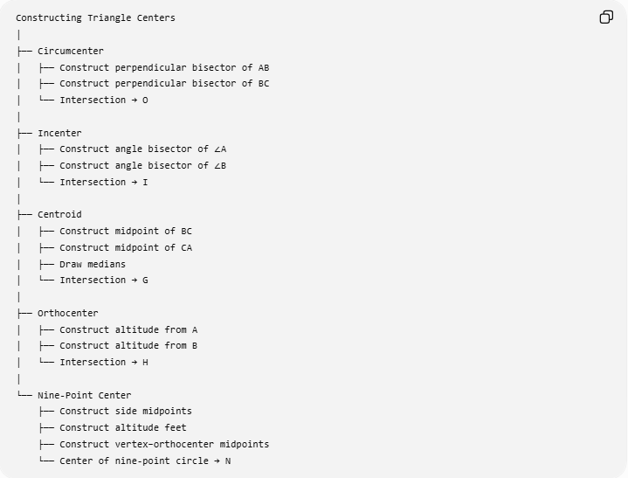
Constructing Triangle Centers
│
├── Circumcenter
│ ├── Construct perpendicular bisector of AB
│ ├── Construct perpendicular bisector of BC
│ └── Intersection → O
│
├── Incenter
│ ├── Construct angle bisector of ∠A
│ ├── Construct angle bisector of ∠B
│ └── Intersection → I
│
├── Centroid
│ ├── Construct midpoint of BC
│ ├── Construct midpoint of CA
│ ├── Draw medians
│ └── Intersection → G
│
├── Orthocenter
│ ├── Construct altitude from A
│ ├── Construct altitude from B
│ └── Intersection → H
│
└── Nine-Point Center
├── Construct side midpoints
├── Construct altitude feet
├── Construct vertex–orthocenter midpoints
└── Center of nine-point circle → N

The Four Classical Triangle Centers
# Source: AI Source: Provided by: [Data Path: Persons Table -> ID Column: 1, Name_En Column: Motasem Essam] -> From: [ChatGPT] on [7/25/2026]
The four most commonly studied triangle centers are:
$$\boxed{O, I, G, H}$$
where:
$$O=\text{circumcenter} \\ I=\text{incenter} \\ G=\text{centroid} \\ H=\text{orthocenter}.$$
Their construction methods are fundamentally different:
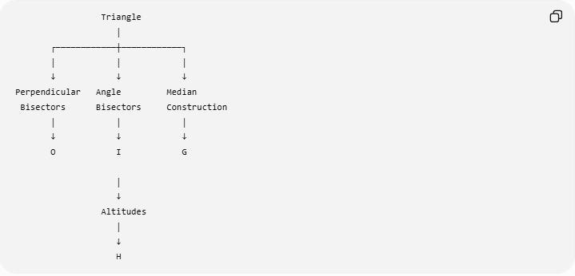
Triangle
│
┌────────────┼────────────┐
│ │ │
↓ ↓ ↓
Perpendicular Angle Median
Bisectors Bisectors Construction
│ │ │
↓ ↓ ↓
O I G

│
↓
Altitudes
│
↓
H

Euler Line
# Source: AI Source: Provided by: [Data Path: Persons Table -> ID Column: 1, Name_En Column: Motasem Essam] -> From: [ChatGPT] on [7/25/2026]
For a general triangle, the circumcenter $O$, centroid $G$, and orthocenter $H$lie on the same line called the Euler line.
$$\boxed{O, G, H\text{ are collinear}}$$
The centroid divides the segment joining the circumcenter and orthocenter according to:
$$\boxed{OG:GH=1:2}$$
Equivalently:
$$\boxed{OG=\frac{1}{3}OH}$$
and:
$$\boxed{GH=\frac{2}{3}OH}.$$
The nine-point center $N$also lies on the Euler line:
$$\boxed{O, N, G, H\text{ are collinear}}$$
with $N$the midpoint of $OH$.
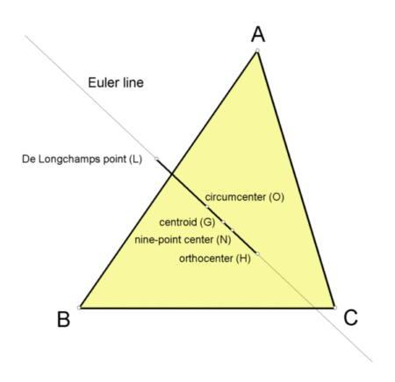
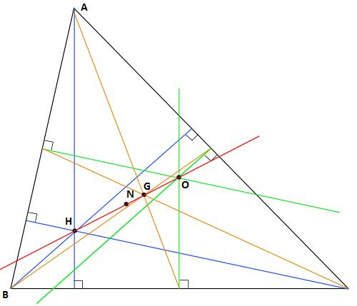
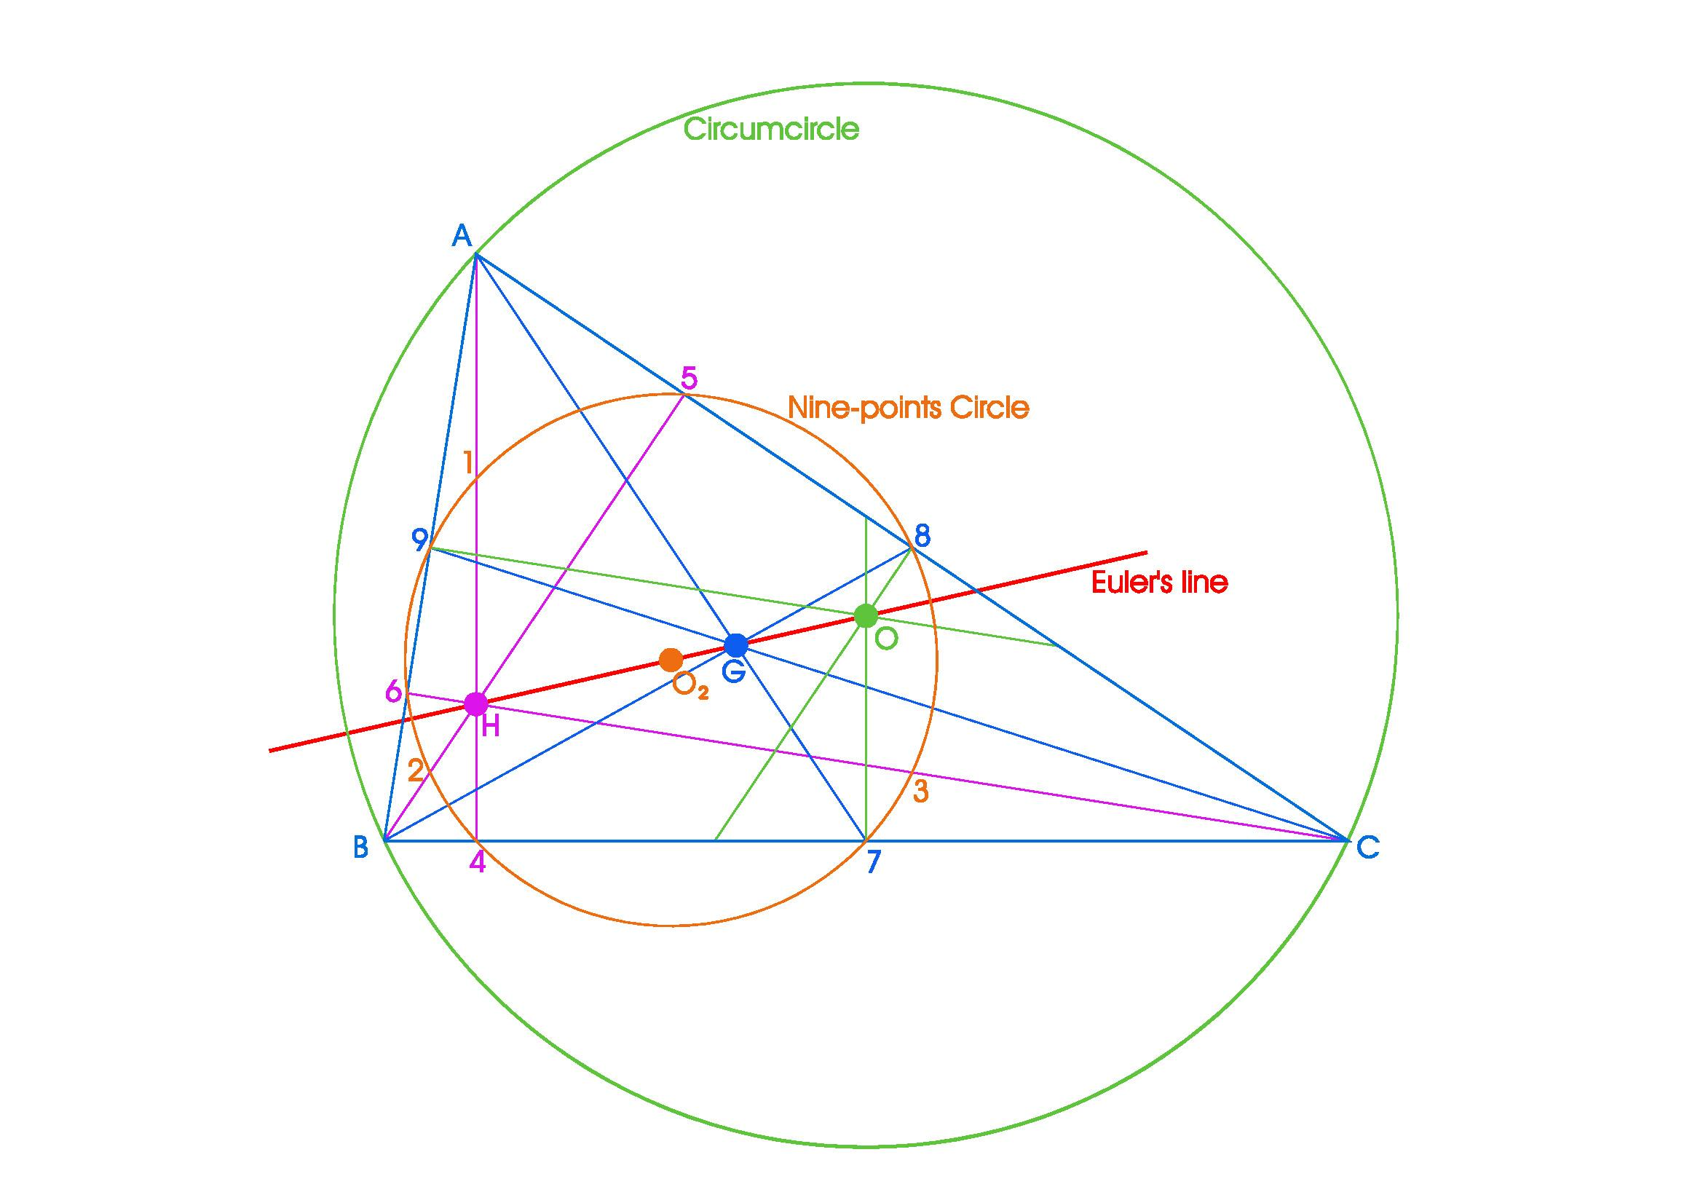
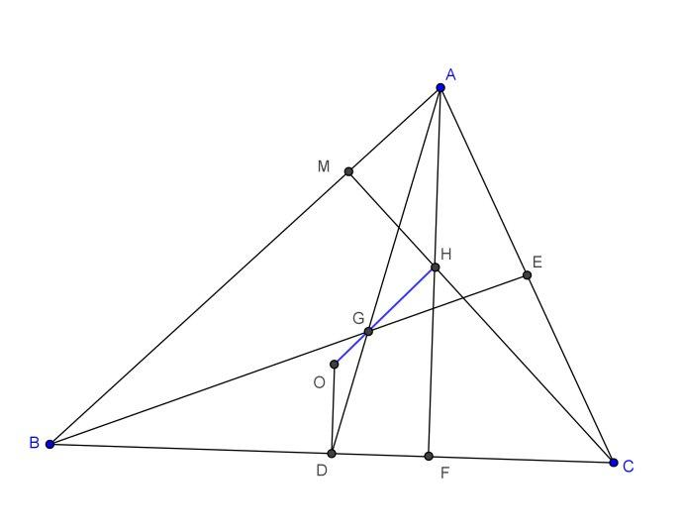

Special Case: Equilateral Triangle
# Source: AI Source: Provided by: [Data Path: Persons Table -> ID Column: 1, Name_En Column: Motasem Essam] -> From: [ChatGPT] on [7/25/2026]
For an equilateral triangle, the major centers coincide.
$$\boxed{O=I=G=H}$$
The perpendicular bisectors, angle bisectors, medians, and altitudes are the same lines.
Thus one point serves simultaneously as:
- circumcenter,
- incenter,
- centroid,
- orthocenter.
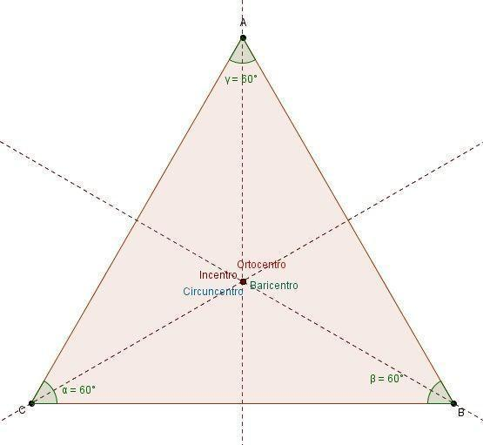
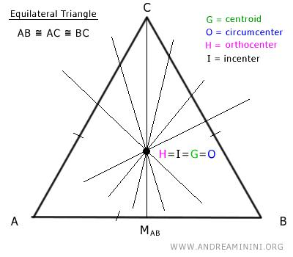
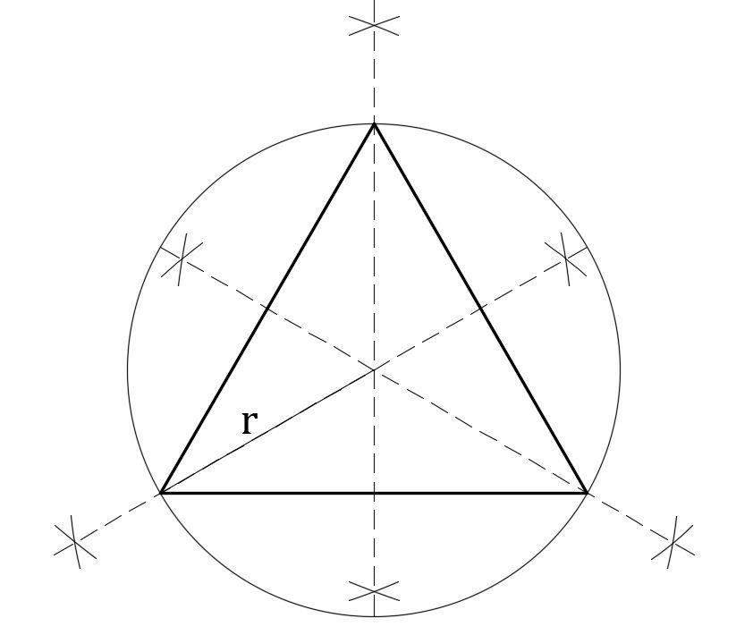

Special Case: Right Triangle
# Source: AI Source: Provided by: [Data Path: Persons Table -> ID Column: 1, Name_En Column: Motasem Essam] -> From: [ChatGPT] on [7/25/2026]
For a right triangle:
Circumcenter
The circumcenter is the midpoint of the hypotenuse.
If $AB$is the hypotenuse:
$$\boxed{O=\text{midpoint of }AB}$$
Orthocenter
The orthocenter is the vertex containing the right angle.
If:
$$∠C={90}^{∘},$$
then:
$$\boxed{H=C}.$$
Centroid
The centroid remains the intersection of the three medians.
Incenter
The incenter remains the intersection of the three angle bisectors.

Special Case: Isosceles Triangle
# Source: AI Source: Provided by: [Data Path: Persons Table -> ID Column: 1, Name_En Column: Motasem Essam] -> From: [ChatGPT] on [7/25/2026]
In an isosceles triangle, the line of symmetry contains several centers.
For example, if:
$$AB=AC,$$
then the symmetry axis through $A$and the midpoint of $BC$contains:
$$\boxed{O, I, G, H}$$
for the corresponding centers.
This provides a useful construction shortcut.

Construction Tools
# Source: AI Source: Provided by: [Data Path: Persons Table -> ID Column: 1, Name_En Column: Motasem Essam] -> From: [ChatGPT] on [7/25/2026]
The main classical tools are:
Tool | Purpose
Straightedge | Construct lines and segments
Compass | Transfer distances and construct arcs
Protractor | Can measure/construct angles in practical settings
Pencil | Mark construction points and lines
For classical straightedge-and-compass construction, the primary tools are:
$$\boxed{\text{Straightedge + Compass}}$$

Construction Sequence
# Source: AI Source: Provided by: [Data Path: Persons Table -> ID Column: 1, Name_En Column: Motasem Essam] -> From: [ChatGPT] on [7/25/2026]
A general procedure for constructing triangle centers is:
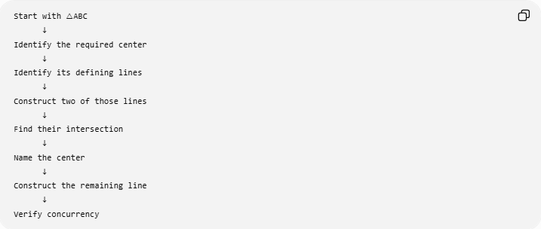
Start with △ABC
↓
Identify the required center
↓
Identify its defining lines
↓
Construct two of those lines
↓
Find their intersection
↓
Name the center
↓
Construct the remaining line
↓
Verify concurrency
For example, for the circumcenter:
$$△ABC \\ ↓$$
perpendicular bisectors
$$↓$$
intersection $O$
$$↓ \\ OA=OB=OC.$$

Verification
# Source: AI Source: Provided by: [Data Path: Persons Table -> ID Column: 1, Name_En Column: Motasem Essam] -> From: [ChatGPT] on [7/25/2026]
After constructing a triangle center, verify its defining property.
Circumcenter
$$\boxed{OA=OB=OC}$$
Incenter
$$\boxed{d\left(I , AB\right)=d\left(I , BC\right)=d\left(I , CA\right)}$$
Centroid
$$\boxed{AG:GD=2:1}$$
Orthocenter
$$\boxed{AD⊥BC, BE⊥AC, CF⊥AB}$$
Nine-Point Center
Verify that the nine characteristic points lie on one circle.

Relationship to Geometric Equality
# Source: AI Source: Provided by: [Data Path: Persons Table -> ID Column: 1, Name_En Column: Motasem Essam] -> From: [ChatGPT] on [7/25/2026]
Triangle-center construction also creates important equalities.
Circumcenter
$$\boxed{OA=OB=OC}$$
Incenter
$$\boxed{d\left(I , AB\right)=d\left(I , BC\right)=d\left(I , CA\right)}$$
Centroid
The median division gives:
$$\boxed{AG=2GD}$$
Equilateral triangle
All centers coincide:
$$\boxed{O=I=G=H}.$$
Therefore, constructing triangle centers is closely connected with distance equality, angle equality, segment equality, and ratio equality.

Complete Summary Table
# Source: AI Source: Provided by: [Data Path: Persons Table -> ID Column: 1, Name_En Column: Motasem Essam] -> From: [ChatGPT] on [7/25/2026]
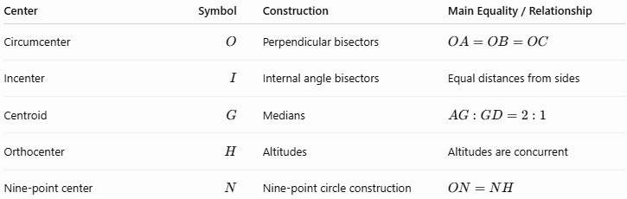
Center | Symbol | Construction | Main Equality / Relationship
Circumcenter | $$O$$ | Perpendicular bisectors | $$OA=OB=OC$$
Incenter | $$I$$ | Internal angle bisectors | Equal distances from sides
Centroid | $$G$$ | Medians | $$AG:GD=2:1$$
Orthocenter | $$H$$ | Altitudes | Altitudes are concurrent
Nine-point center | $$N$$ | Nine-point circle construction | $$ON=NH$$

Key Points
# Source: AI Source: Provided by: [Data Path: Persons Table -> ID Column: 1, Name_En Column: Motasem Essam] -> From: [ChatGPT] on [7/25/2026]
- A triangle center is a special point determined by geometric relationships within a triangle.
- The circumcenter is constructed using perpendicular bisectors.
- The incenter is constructed using internal angle bisectors.
- The centroid is constructed using medians.
- The orthocenter is constructed using altitudes.
- The nine-point center is associated with the nine-point circle.
- Only two of the defining lines generally need to be constructed to locate the center; the remaining line provides a verification of concurrency.
- The circumcenter satisfies:
$$OA=OB=OC.$$
- The incenter is equally distant from all three sides.
- The centroid divides every median in a $2:1$ratio.
- The orthocenter is the common intersection of the altitudes.
- The circumcenter, centroid, orthocenter, and nine-point center lie on the Euler line for a general triangle.
- In an equilateral triangle:
$$O=I=G=H.$$

Conclusion
# Source: AI Source: Provided by: [Data Path: Persons Table -> ID Column: 1, Name_En Column: Motasem Essam] -> From: [ChatGPT] on [7/25/2026]
$$\boxed{\text{Constructing Triangle Centers}=\text{Locating special points by constructing their defining geometric lines}}$$
The central construction relationships are:
$$\boxed{\text{Perpendicular Bisectors}→\text{Circumcenter }O} \\ \boxed{\text{Angle Bisectors}→\text{Incenter }I} \\ \boxed{\text{Medians}→\text{Centroid }G} \\ \boxed{\text{Altitudes}→\text{Orthocenter }H} \\ \boxed{\text{Nine-Point Circle}→\text{Nine-Point Center }N}$$
These constructions demonstrate an important principle of geometric construction:
$$\boxed{\text{Construct Defining Objects}→\text{Find Their Common Point}→\text{Obtain the Triangle Center}}$$

